TECHNOLOGY SECTOR EQUITY ANALYSIS
Price Behaviour, Volume Analysis, and Trading Ideas Development

Submitted by:
Lokesh Golagana

Date: 24 May 2026

- OBJECTIVE

The objective of this analysis is to study price behaviour, volatility, and trading activity within selected technology sector equities and identify potential patterns, trading ideas, and associated risks using historical market data.

- STOCKS SELECTED

COMPANY | TICKER
Microsoft Corporation | MSFT
NVIDIA Corporation | NVDA
Tesla, Inc. | TSLA

- SUMMARY STATISTICS (23 MAY 2025 – 22 MAY 2026)

STOCK | AVERAGE PRICE(USD) | HIGHEST PRICE (USD) | LOWEST PRICE (USD)
MSFT | $466.89 | $542.07 | $356.77
NVDA | $180.90 | $235.74 | $131.29
TSLA | $392.10 | $489.88 | $284.70

The summary statistics provide an overview of the average, highest, and lowest closing prices of each stock during the selected period.

- PRICE TREND ANALYSIS
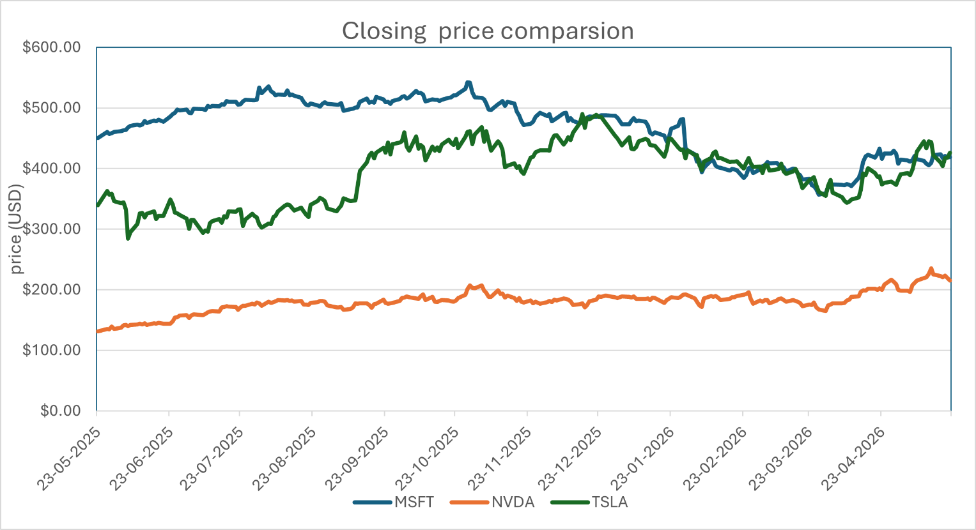

OBSERVATIONS

- Microsoft (MSFT): Microsoft showed relatively stable movement initially, but the stock experienced a gradual decline during the later part of the selected period.
- NVIDIA (NVDA): NVIDIA showed a steady upward trend with gradual price growth and comparatively lower volatility.
- Tesla (TSLA): Tesla experienced higher volatility with frequent sharp increases and decreases in stock price throughout the analysis period.

- TRADING / RISK IDEA

A simple trading idea is to monitor stocks showing strong momentum and stable upward movement, such as NVIDIA, while being cautious with highly volatile stocks like tesla. Investors may consider entering trades during periods of steady upward movement and avoiding trades during sharp unpredictable fluctuations.
Rationale
- NVIDIA showed gradual and consistent upward momentum.
- Tesla experienced sharp price swings, increasing trading risk.
- Microsoft showed relatively stable behaviour but weakened during the later period.

6.HOW THE IDEA WOULD BE TESTED (BACKTESTING APPROACH)
The trading idea can be evaluated using historical stock price data from the selected period. The analysis would focus on identifying periods where stocks showed steady upward momentum and comparing their performance over the following trading sessions.
The strategy can be evaluated by:
- Observing price movement after upward trends
- Comparing stable and volatile stock behaviour
- Measuring short term gains or losses after trade entry
This approach helps determine whether momentum based trading decisions could have produced consistent results using historical market data.
- RISKS / WEAKNESSES
- Market volatility: Technology stocks can experience sudden price fluctuations due to market sentiment and news events.
- Historical Limitations: Past stock performance may not guarantee future results.
- High volatility Risk: Stocks like Tesla may generate unpredictable price movements.
- External Factors: Economic conditions and investors sentiment can strongly impact stock prices.
- Limited Timeframe: The analysis is based on one year of historical data only.

- CONCLUSION

The analysis showed different price behaviours among the selected technology stocks. Microsoft demonstrated relatively stable movement, NVIDIA showed steady upward momentum, and Tesla experienced higher volatility with frequent price fluctuations. The study also highlighted how momentum-based analysis can help identify potential trading opportunities while emphasizing the importance of risk management and historical validation before making trading decisions.

- AI USAGE STATEMENT
I confirm that I used AI tools only for the following purposes:
- Reporting structuring and formatting support
- Improving clarity and grammar in writing
- Refining explanations and presentation style
All data collection, Excel analysis, Chart preparation, observations, interpretations, and conclusions are my own work.

- APPENDICES
- Appendix A: Raw historical stock data (MSFT, NVDA, TSLA)
- Appendix B: Summary statistics table
- Appendix C: Comparative price trend chart
- Appendix D: Supporting excel calculations and analysis tables

